NOW OPEN TO FRIENDS OF THE SCUBA SPORTS CLUB
ONLY 9 SPOTS REMAIN
Optional/Tentative Land Tour July 22-26^{th (price not determined)}
LIVEABOARD July 27- August 3, 2024
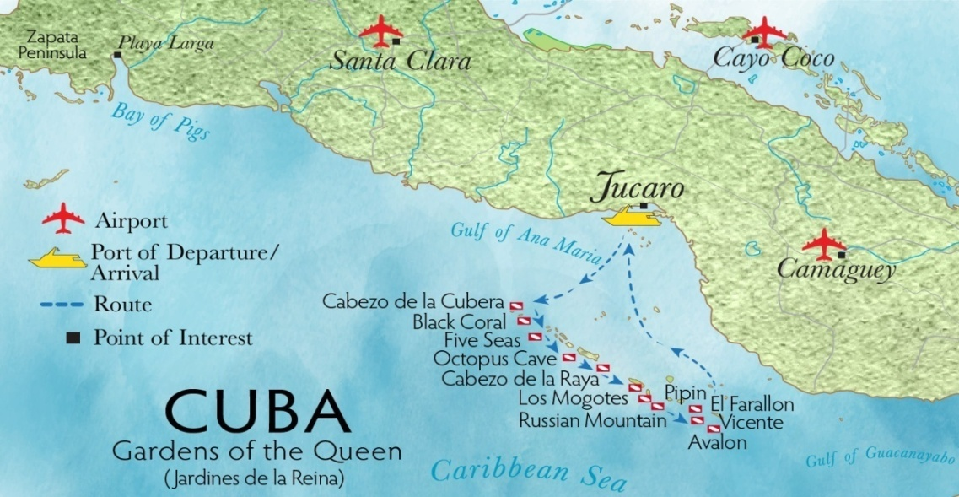

JardinesAggressor II
https://www.aggressor.com/boat/JAII
Deluxe Cabin: $3,800 USD (double occupancy/member price)
15% Discount If $760 Deposit Paid by 12/20/23
15% discount reimbursed after final payment
**Price listed are before comps- up to a max $600/ea.**

Included:
7 nights on board the Aggressor II
Meals/beverages
3-4 dives per day

Not included:
Flights to Santa Clara or Camaguey
Nitrox: $120/week
Port Fee $240
Conservation Fee: $120
Airport Transfers TBA
PLEASE NOTE:
Do NOT book your flights until you have received confirmation of your spot.
Our club requires membership or 10% fee added to the cost of the trip. Each person diving MUST have Dive insurance.
3% fee if paid by credit card
Single supplement is double the cost

*The benefit of going with the group is sharing comps and commissions. You will be invoiced directly by Aggressor. Portion of trip could be tax write off (ask your accountant)
Frequently asked questions.
https://www.aggressor.com/pages/cuba-questions
We plan on selling this out.
Note: Optional land tours are still being worked on.(3-4 days pre-live aboard.) Deposits due ASAP to hold your spot on the boat.
Any Questions Please Email:diveplanner@thescubasportsclub.org

HOLD YOUR SPOT- SEND YOUR NAME AS IT APPEARS ON YOUR PASSPORT TO JACK

